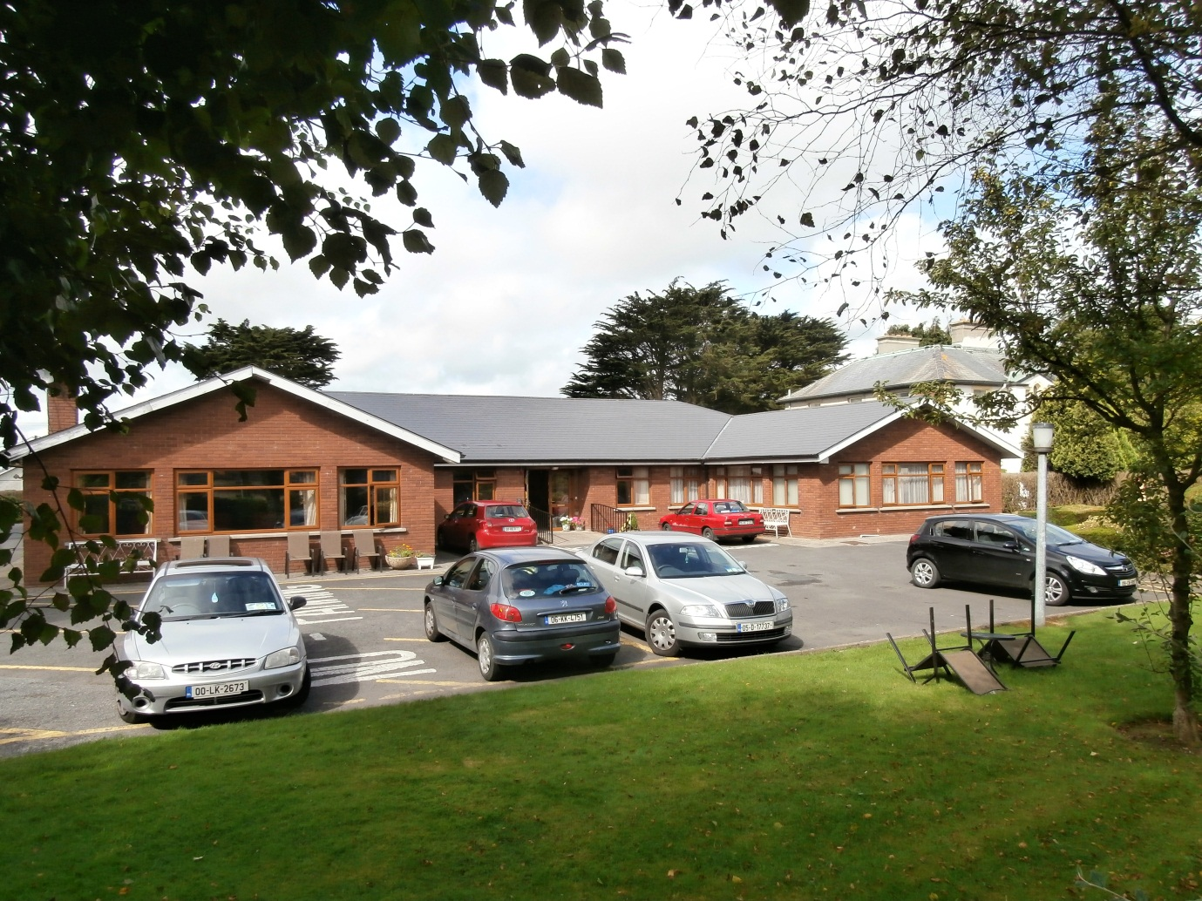

Annual Report 2019

Index
- Chairperson Introduction……………………………………………………………………………………………..P3
- Residents / Occupancy………………………………………………………………………………………………….P4
  - Gender Profile………………………………………………………………………………………………….. P4
  - Age Profile………………………………………………………………………………………………………… P4
  - Length of Stay (LOS)………………………………………………………………………………………….. P4
  - Permanent / Respite ………………………………………………………………………………………… P4
  - Discharge & Transfers……………………………………………………………………………………….. P5
- Incidents and Accidents………………………………………………………………………………………………..P5
- Complaints and Feedback……………………………………………………………………………………………..P6
- Residents Consultations………………………………………………………………………………………………..P6
  - Residents/House meetings…………………………………………………………………………………P6
  - Health & Safety meetings…………………………………………………………………………………..P6
  - Food & Meals Group…………………………………………………………………………………………..P7
  - Residents Satisfaction Questionnaire ……………..…………………………………………………P7
- Activities……………………………………………………………………………………………………………………….P7
- Staffing………………………………………………………………………………………………………………………….P8
  - Staff Training……………………………………………………………………………………………………..P9
- Volunteers…………………………………………………………………………………………………………………….P9
- Governance…………………………………………………………………………………………………………………..P9
9.1Sub-committees…………………………………………………………………………………………….…...P9
  - Organisational Governance Commitments…………………………………………………………P9
- Bungalows…………………………………………………………………….…….……………………………… P10
- Meals on Wheels ……………………………………………………………………………………………….…. P10
- Day Service………………………………………………………………………………..……………………….… P10
- Networking …………………………………………………………………………………………………………..P10
  - Cross Community Links Choir ………………………………………………………………….. P10
  - Supported Care Homes Advisory Group ………………………………………………….. P10

Appendix 1: Incident and Accident Form
Appendix 2: Complaints and Feedback Form
Appendix 3: Residents Satisfaction Questionnaire
Appendix 4: Results of Residents Satisfaction Questionnaire
Appendix 5: The Governance Code

- Chairperson Introduction:

In 2019 we built on the response to the challenges of 2018. We had another inspection in January 2019 and again this necessitated the development of a compliancy plan which was undertaken by the PIC and the board members.

2019 was a very stable year for the people we support in Mount Carmel, we only had 6 admissions and 2 of those admissions were for respite care. Likewise our staff team was also very stable and all the new who joined in 2018 and 2019 embedded themselves into the staff team and the workings of the home.

Again we faced financial challenges like many of the homes in the region of Kilkenny/ Carlow, again we thank the HSE for their support around the funding challenges and with their support in overcoming the challenges in 2019.

In total we supported 24 people in 2019 in the Centre and further insight can be seen in the annual report in relation to length of stay etc. I would suggested that you take to look at the results of resident’s consultation that took place in 2019, this can be seen in appendix 3 & 4.

We provide close to 4000 home meals to people living in the community through the meals on wheels service and provided independent living accommodation in our Bungalows to 10 people in 2019 in addition to the services provided in the Centre.

Can I thank all those who supported Mount Carmel in 2019 from our partners in HSE, to our stakeholders such as family members, all those who donated money, and all the people who supported the annual Callan Golf Club Classic in aide of Mount Carmel in August. It was one of the most successful Golf Classics ever.

Finally can I thank all the staff for their work and efforts in 2019 and also my fellow Board members for their dedication and time in ensuring that Mount Carmel Supported Care Home in meeting the challenges going forward and the needs of the people we supported in 2019.

Matt Doran
Chairperson
March 2020

2.0 Residents / Occupancy:
In 2019 there were 24 residents who resided in Mount Carmel Supported Care Home (MCSCH), the capacity from a bed perspective is 20 beds and 6 of these residents were new admissions. The 6 new residents consisted of 4 permanent residents and 2 respite residents.

Reflecting on the previous year of 2018 where there were 10 new residents, 2019 was a more stable year with only 6 new admissions to the Centre.

2.1 Gender Profile:
As can be seen from figure 2.1 58% of the residents were male with females consisting of a little over 42% of the residents the Centre in 2019

Gender | Numbers | Percentage
Female | 10 | 42%
Male | 14 | 58%
Total | 24 | 100%
Fig: 2.1

2.2 Age Profile:
The age profile of the residents in home has remained reflective of the age profile for 2018. The youngest person was 56 and oldest was 94. The average age of the resident is 80 years of age. Highlighted in Figure 2.2

Gender | Average age | Oldest
Female | 89 yrs. | 94 yrs.
Male | 79 yrs. | 90yrs.
Fig: 2.2

2.3 Length of stay (LOS):
The longest stay of a resident in the Center is nearly 12 years. Excluding the respite residents 50% of residents have been making Mount Carmel their home for over 3 years. An over view of LOS is outlined in Figure 2.3.

Length of Stay | Number | Percentage
<1 year | 4 | 18%
1-3 years | 7 | 32%
3-7 years | 6 | 27%
7 +years | 5 | 23%
Total | 22* | 100%
Fig: 2.3 *Excludes respite clients

2.4 Permanent / Respite:
As already noted 24 people used the service in 2019, of the 24 people 2 were respite clients. These figures are out lined below in Figure 2.4.

Residency type | Numbers | Percentage %
Permanent | 22 | 92%
Respite | 2 | 8%
Fig: 2.4

2.5 Discharges / Transfers:
In 2019 the Centre had only 4 discharges from service and this includes the 2 respite residents.

Discharge / Transfer | Number | Percentage
Nursing Home | 2 | 50%
Home | 2* | 50%
Fig 2.5 *Respite clients

3.0 Incidents and Accidents:
A new method of recording incidents and Accidents was introduced in 2019. (Appendix 1). This new method involved a tick box reporting structure prior to that the system involved writing a description of the incident in a duplicate book. This could lead to ambiguity around the describing of incidents where the new system was more structured.

In total we recorded 55 incidents in 2019, 3 of these were errors in the reporting due to errors in the duplication book in the old system.

Of the 52 actually recorded incidents the highest was in the category of falls/slips/trips. In total there was 20 recorded incidents which represents 38% of all recorded incidents. While the vast amount of these incidents were of a minor impact 4 did require medical attention resulting in 3 hospitalizations.

The second highest type of incident recorded was medication errors, we recorded 7 errors which amounted to 13% of all incidents. Again on further investigation the majority of incidents where of a minor level but the recording of such incidents impacted on practice and policy.

Outside of the clients the highest reported group where day attenders and tenants of the bungalows, these 2 groups recorded 19% of all reports. The incidents included reports on intruders, minor vehicle collisions and day attenders requiring medical assistance.

Other incidents that were reported included behavior that Challenges (3/6%), Burn (1/ 2%), verbal assault (5/10%) and a Physical assault (1/ 2%).

Again the above incidents where of a minor nature but the actual recording allowed us to monitor and respond to the incidents through practice and policy.

All incidents and accidents are reported to the Board of management on a monthly basis via the manager’s monthly report.

4.0 Complaints and Feedback:
Similar to the incidents and accidents a new system of providing Complaints and feedback was introduced in 2019 (Appendix 2), again this provided a more structured approach in providing complaints and Feedback.

In 2019 9 complaints/feedback forms where completed. There was a variety of issues highlighted that included the following:
- Behavior that challenges
- Fellow residents
- Service Delivery
- Theft / Allegations
- Breach of privacy

All complaints and feedback where addressed to the satisfaction of the person making the complaint. As part of providing and creating a culture that welcomes feedback all residents are encouraged to provide feedback and the item is placed on the agenda of the house meetings.

Similar to the incidents and accidents from all complaints and feedback information is recorded in the manger’s monthly report which is presented to the Board of Management for consideration.

5.0 Residents Consultation:
The center engages in several methods around consultation with the residents and supporting the residents to be active in the Centre.

5.1 Resident / House meetings:
In 2019 there were 10 house meetings that took place throughout the year with on average 12 residents attending the meetings. Topics for the meetings included some the issues outlined below:

- Health and Safety Committee Feed back
- Meals and Food group feed back
- Complaints and feed back
- Sage Advocacy
- Social events
- Electoral Register
- HIQA
- Fire Drills
- Decoration of the sitting room/ bedrooms

5.2 Health & Safety meeting:
The Health & Safety committee met several times throughout 2019. The committee consists of staff and residents of Mount Carmel and the following topics where covered:
- Weather warnings
- Safety Signage
- Fire safety.
- Heating times
- Lighting
- Security

5.3 Food & Meals Group:
The group met 4 times throughout 2019 to provide feedback and suggestions on the meals and food provided in Mount Carmel

5.4 Residents Questionnaires:
A Resident’s questionnaire was completed in 2019 and provided feedback and suggestions from the residents.

The questionnaire is attached (Appendix 3) and a report that was developed from the questionnaires that were returned (Appendix 4) is also attached.

Below are some quotes taken from the various questionnaires that were returned:

- Reassuring when you have somebody to bring you to appointments and a great help to my family.

- Friendly and clean

- Enjoy meal times but would like a steak!

- Not always –This comment was made in relation to “Can your friends and relatives visit any time that suits them?”

- Very inviting, stress free and treated with respect. Great that you call anytime and always be made feel part of a bigger family.

- Make my room more homely. Need a more comfortable seat in room for watching TV. Maybe change the color on the walls in bedroom

- Possibly! That a new staff member person be introduced to some residents who may be wary-apprehensive of strangers in the confines of their bedrooms, familiar faces etc when one feels vulnerable.

6.0 Activities:
The range of activities offered in Mount Carmel include the following:

- Facilitated Artwork and memory Art activities
      - Bingo
      - Hairdressing
      - Daily Mass
      - Music
      - Individualised Activities based on Care Plan.
      - Cinema Night

Other activities included visits to the theater and community outings. In 2019 a cross community choir was developed in conjunction with the Irish Wheel Chair Association (IWA) and the Larche Community of Callan. The community Gardaí also supported this initiative and resulted in several performances throughout the Christmas period of 2019. It is hope that this Cross Links Choir will continue in 2020

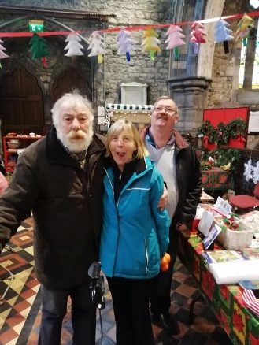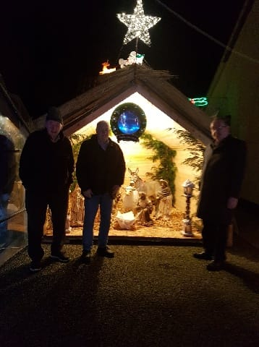

As a Centre we held a remembrance night during the Christmas period, this is where we opened our doors to the broader Callan community and invited families in to participate in a remembrance and an evening of song provided by the residents.

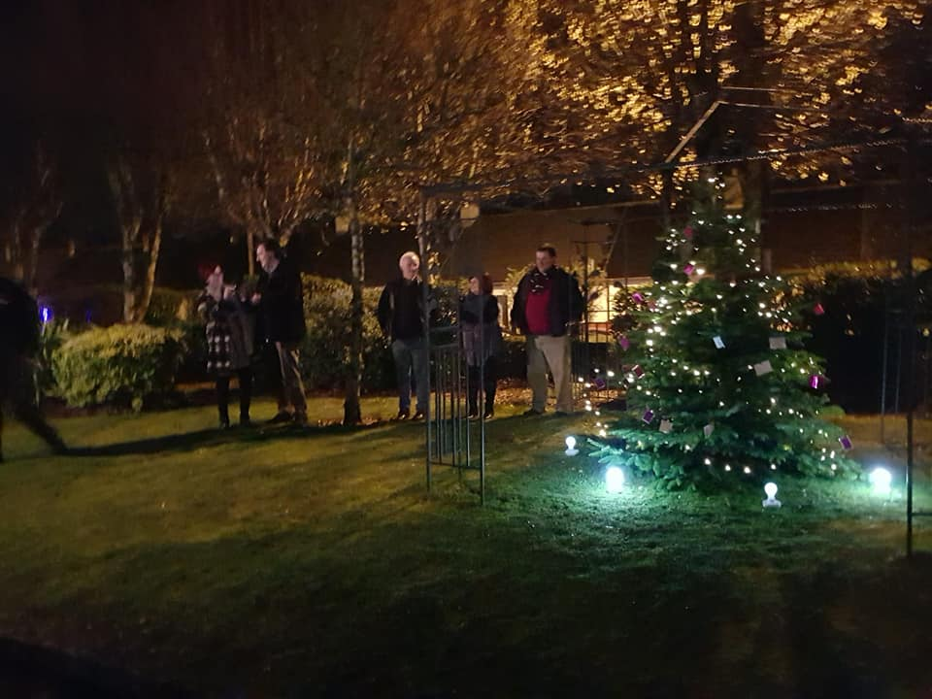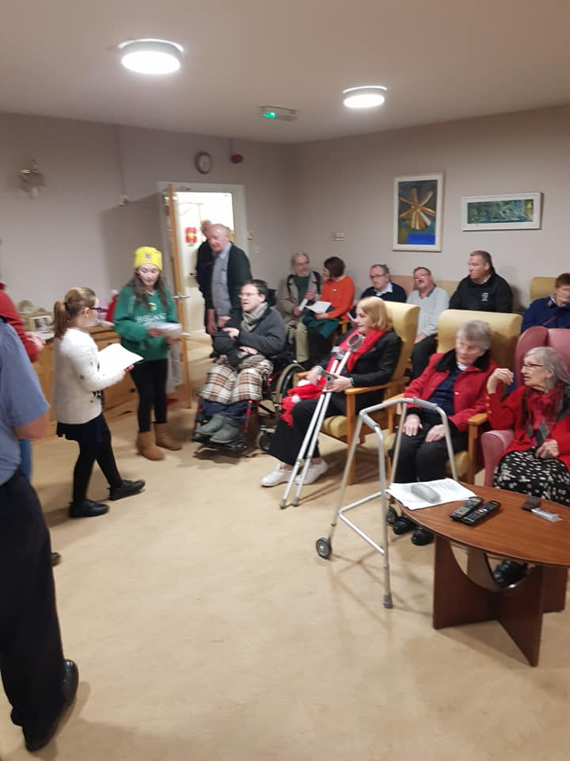

7.0 Staffing:
2019 was a stable year for staff, as we only had one member of the team leave and one member of the CE Scheme leave.

We saw 2 new members of staff joining the relief panel and a 2 new CE staff.

7.1 Staff training:
The ongoing training with staff continued in 2019 with the following areas been addressed:

- First Aid Responder FAR (refresher)
- Comprehensive Fire Training

8.0 Volunteers:
Two volunteers started in 2019 both supporting clients to attend and engage with community events.

- Governance:
The board of Directors met 10 times in 2019, please see figure 9.0

Date | Meeting Type
29.01.2019 | General
26.02.2019 | General
26.03.2019 | General
30.04.2019 | AGM
28.05.2019 | General
25.06.2019 | General
30.07.2019 | General
24.09.2019 | General
29.10.2019 | General
26.11.2019 | General
Fig: 9.0

9.1 Sub committees:
As part of the development of enhanced governance structures the sub-committee structure of Mount Carmel was enhance with the development of additional sub-committees. These are outlined below in figure 9.1.

Sub-committee | Chairperson/s
Financial | Pattie McGuire / Frank McKenna
Human resources (HR) | Eoin Carey
Governance | Fergus Horgan
Fig. 9.1

9.2 Organisational Governance Commitment:
As part of the commitment to Governance excellence Mount Carmel committed to both the Charities Governance Code and the Governance Code (Appendix 5).

The Governance Code is now defunct and has been replace by the Charities Governance Code.

- Bungalows:
The Centre provides independent living accommodation on the grounds of Mount Carmel, through the provision of 8 bungalows on the grounds. Currently there are 10 tenants living in the bungalows and a new tenant took up residency in 2019

- Meals on Wheels:
The Centre provides meals on wheels to the broader Callan Community and in 2019 approximately 3900 meals where supplied and delivered by HSE staff.

- Day Service:
A day service is provided to the broader Callan Community and the following services are provided:

- Social Activities
- Lunch
- Chiropody
- Hairdressing
- Bingo
- Art and crafts
- Music therapy
- Collecting and dropping home by MC Staff.

Several people attend the Centre for dinner and social connection every day. Up to 12 people can avail of the day service provision.

- Networking:
Mount Carmel has developed strong networking elements to the service, these networking elements include both social and organisational.

13.1 Cross Community Links Choir:
The choir was set in late 2019 in conjunction with the Irish Wheelchair Association (IWA), the Larche Community and Mount Carmel. The choir rehearses in Mount Carmel and had performances in several locations around the Christmas period. It is envisaged the choir will continue in 2020.

13.2 Supported Care Homes Advisory Group:
This group was newly formed in 2019 and consists of all the care homes in Kilkenny and Carlow. The group meets every quarter with ALONE and HSE representatives. Its primary role is networking and enhancing the work of the group homes.

Appendix 1:

Please: indicate the injured person's level of distress following the incident according to the following scale:
- No Distress
- Shock or Tears at the time
- Avoidance of Person or Place
- Prolonged Tears
- Other I specify:

Appendix 2:

Appendix 3:

Appendix 4:

Appendix 5:

